***RACE MANAGER APPLICATION***

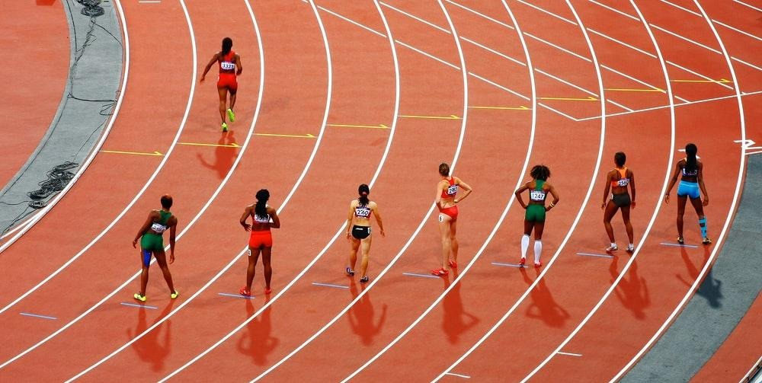

***Tien Le - 292104***

***CIS 223 - 40***

***Course Project***

# Table of content

**Table of content** **1**

**Introduction - An overall look** **4**

**Instructions - The user manual** **5**

Step 1: Starting up the program 5

Step 2: Selecting your options 5

Step 3: Putting in the teams 6

Step 4: Loading the runners 11

Step 5: Accessing the time files 15

Step 6: Seeing the results 18

**Appendix A - Design documentations** **21**

**Appendix A.1 - frmRMSplash.vb** **21**

Requirements documents 21

Use case definition 21

**Appendix A.2 - frmRM0000.vb** **22**

Requirements documents 22

Use case definition 23

**Appendix A.3 - frmRM1000.vb** **24**

Requirements documents 24

Use case definition 25

**Appendix A.4 - frmRM2000.vb** **26**

Requirements documents 26

Use case definition 27

**Appendix A.5 - frmRM3000.vb** **28**

Requirements documents 28

Use case definition 29

**Appendix A.6 - frmRM4000.vb** **30**

Requirements documents 30

Use case definition 31

**Appendix B - Test results** **32**

**Appendix B.1 - The short version** **32**

frmRMSplash [Splash Form] 32

frmRM0000 [Main Menu] 33

frmRM1000 [Team Management] 33

frmRM1000 - [Load Teams] 34

frmRM1000 - [Add Teams] 35

frmRM1000 - [Delete Teams] 36

frmRM2000 [Runners Management] 37

frmRM2000 - [Load Runners] 38

frmRM2000 - [Add Runners] 38

frmRM2000 - [Del. Runners] 39

frmRM3000 [Time Management] 40

frmRM3000 - [Load Times] 41

frmRM3000 - [Enter BIB #s] 41

frmRM3000 - [Sync] 42

frmRM4000 [Results Management] 42

frmRM4000 - [Calculate Res.] 43

frmRM4000 - [Archive File] 43

Sample Text File Output File 44

**Appendix B.2 - The full version** **45**

frmRMSplash [Splash Form] 45

frmRM0000 [Main Menu] 46

frmRM1000 [Team Management] 46

frmRM1000 - [Load Teams] 47

frmRM1000 - [Add Teams] 47

frmRM1000 - [Delete Teams] 49

frmRM2000 [Runners Management] 50

frmRM2000 - [Load Runners] 50

frmRM2000 - [Add Runners] 51

frmRM2000 - [Del. Runners] 52

frmRM3000 [Time Management] 53

frmRM3000 - [Load Times] 53

frmRM3000 - [Enter BIB from C:\Bob\BIBPositions.txt] 54

frmRM3000 - [Sync] 54

frmRM4000 [Results Management] 55

frmRM4000 - [Calculate Res.] 55

frmRM4000 - [Archive File] 56

Sample Text File Output File 56

**Appendix C - The source code** **57**

**Appendix C.1 - frmRMSplash.vb** **57**

**Appendix C.2 - frmRM0000.vb** **57**

**Appendix C.3 - frmRM1000.vb** **59**

**Appendix C.4 - frmRM2000.vb** **63**

**Appendix C.5 - frmRM3000.vb** **67**

**Appendix C.6 - frmRM4000.vb** **73**

**Appendix C.7 - RosterLoad.txt** **79**

**Appendix C.8 - TimeFile.txt** **81**

**Appendix C.9 - BIBPositions.txt** **83**

**Appendix C.10 - RosterLoadshort.txt** **85**

**Appendix C.11 - TimeFileshort.txt** **86**

**Appendix C.12 - RaceMgr-Result_TienLe.txt** **86**

# ***Introduction - An overall look***

The Race Manager is a program originally made by Bob Desilets. However it was just a shell with little to no code in it, making it *almost* unusable. The program published alongside this instruction manual is modified and streamline by me, Tien Le, the author and a student of Bob. The main purpose of this program is to keep track of all the information of a race, marathon such as the teams, the runners, the position of each runner when they finished the race and calculate results for each team, and even individual results. The results can be printed out as a text file if the user desired to.

I have put much time into this program, from trying arrays to using global variables, and ultimately decided to scrap all of them and start fresh with just simply copying line to line from the text file to the list box object. I am known for overthinking things in the past, and it is not surprising that he did the same when starting out this project. After coding the load functionality for the program, I move on to coding the delete button, which is simply removing an item in a list box. Coding for the add button was not hard, but I am not happy with the result, despite it working in the final version, see *step 3* of the instruction for more information.

Once the code for the three buttons had finished, Irealised that most of the other buttons functioned the same and therefore did not take much time to finish the other ones. The last obstacle was of course the formatting of the final output text file. I had taken some time to think how to properly format them in a straight vertical column, and decided to use many spaces and zero-leading numbers to align all of them. The author is not proud of this part, since it is such a mess, see source code frmRM4000 for more information.

Overall, this final project is very hard to get into. But thanks to some existing code with the shell, I was able to finish the project earlier than expected, and managed to snowball from there. I hope the person reading this can understand what I have done with the program and my struggles throughout this work.

# Instructions - The user manual

## Step 1: Starting up the program

* When the user first starts up the program, you should be able to see a beautiful splash screen that shows a picture of a marathon.
* After 4 seconds, the main program shows up.

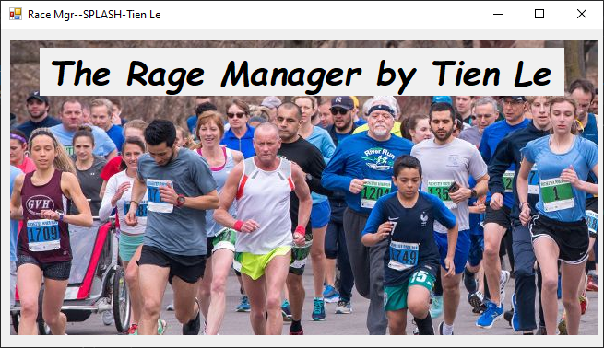

## Step 2: Selecting your options

* The program main menu frmRM0000 opens up with the following options
  + A text box containing the file path to the Roster Load text file
    - The default path is “**C:\Bob\RosterLoad.txt**”
  + Four buttons:
    - Team Manager **[1-Team Mgr]**
    - Runner Manager **[2- Runner Mgr]**
    - Race Manager **[3- Race Mgr]**
    - Results Manager **[4 - Result Mgr]**
* An exit button on the bottom right

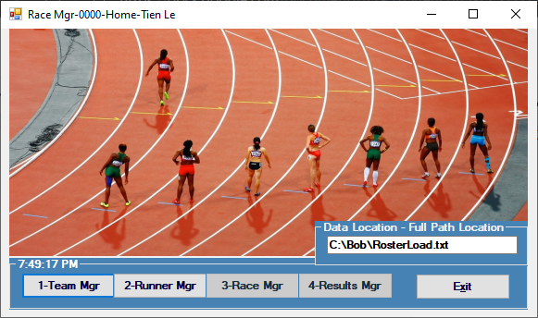

* For now, buttons [3 - Race Mgr] and [4 - Result Mgr] are not enabled because those forms require information from form frmRM1000 and frmRM2000. These forms can be access and fill out through the buttons [1- Team Mgr] and [2 - Runner Mgr] respectively
* Click **[1 - Team Mgr]** to open up frmRM1000

## Step 3: Putting in the teams

* The form frmRM1000 opens up with the following objects
  + A blank list box
  + A cute corgi jumping over the snow (*very important*)
  + A text box containing the same file path in frmRM0000
  + Three functional buttons
    - Load Teams **[Load Teams]**
    - Add Teams **[Add Teams]**
    - Delete Teams **[Delete Teams]**
  + A return button on the bottom right of the form

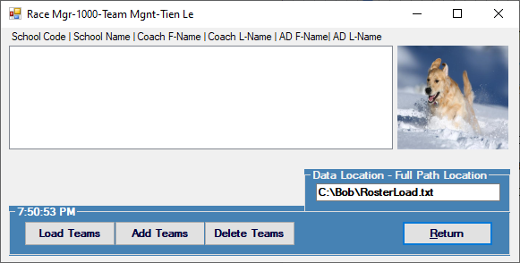

* Let’s start by adding the teams. Click **[Load Teams]** to load in the team from the file path. The program will input blanks if you do not have the right text file in the correct file path. Please double check if the program doesn’t show anything in the list box.

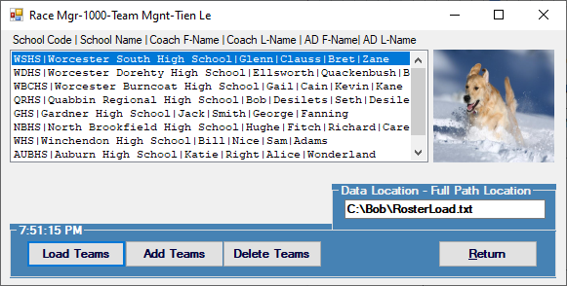

* To add teams, simply click **[Add Teams]**.An input box will show up and ask for the following informations:
  + School code
  + School name
  + Coach’s first name
  + Coach’s last name
  + AD’s first name
  + AD’s last name

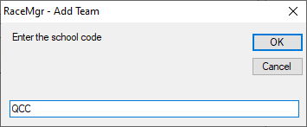

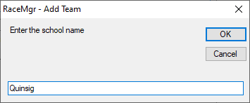

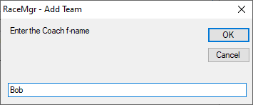

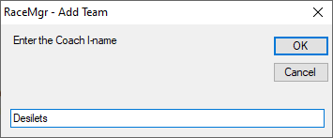

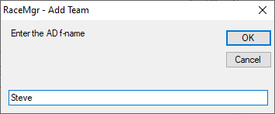

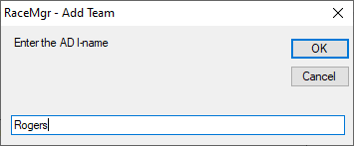

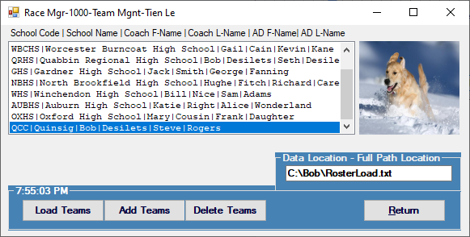

* Note: Because this is an input box, when the user clicks **[Cancel]** *it does not end the input procedure. The cancel button returns an empty string and therefore the program accepts the string as it and keeps on asking for the next information on the list above. You can not input a duplicating value.*
* Now that you have added a team, let’s try to delete it by clicking on the team you’ve just input (should be in the bottom of the list) and click **[Delete Teams]**. A prompt will show up to let you know you’re about to delete a team.

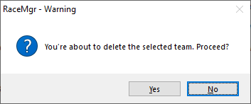

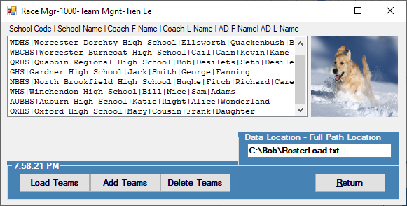

* Click **[Return]** to return to the main menu frmRM0000
* Select **[2 - Runner Mgr]** to open frmRM2000

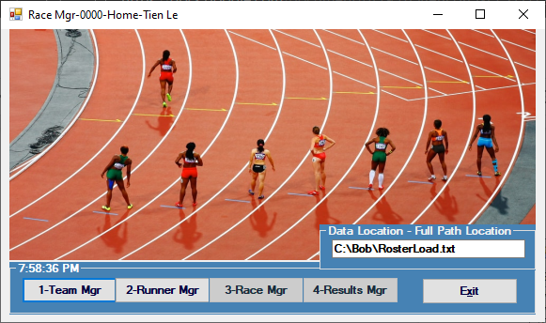

## Step 4: Loading the runners

* The form frmRM2000 opens up with the following objects
* A blank list box
* Another cute corgi jumping over the snow (*very important!*)
* A text box containing the same file path in frmRM0000
* Three functional buttons
  + Load Runners **[Load Runners]**
  + Add Runners **[Add Runners]**
  + Delete Runners **[Del. Teams]**
* A return button on the bottom right of the form

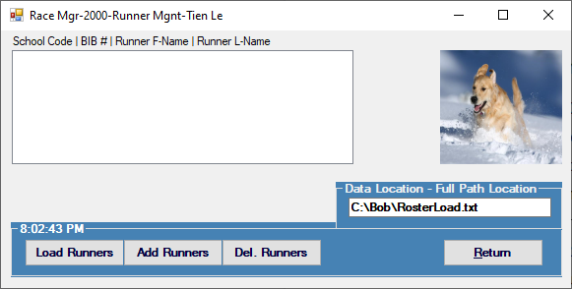

* With mostly the same steps, let’s start by adding the runners. Click **[Load Runners]** to load in the runners from the file path. The program will input blanks if you do not have the right text file in the correct file path. Please double check if the program doesn’t show anything in the list box.

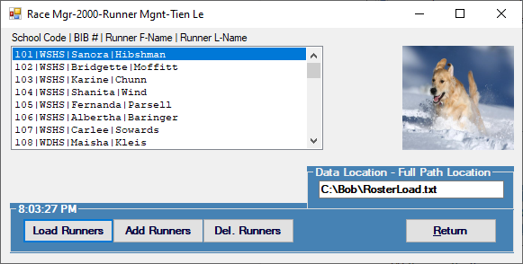

* To add runners, simply click **[Add Runners]**.An input box will show up and ask for the following information:
* School code
* BIB number
* Runner’s first name
* Runner’s last name

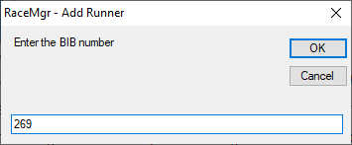

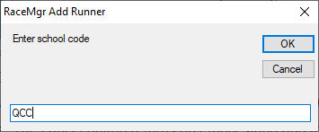

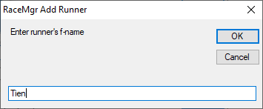

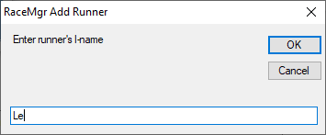

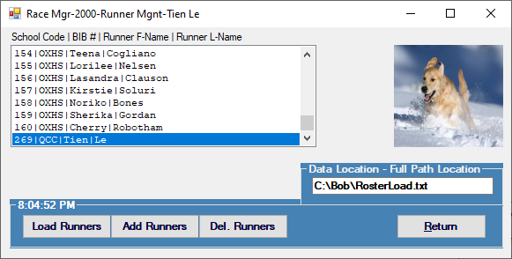

* Note: Because this is an input box, when the user clicks **[Cancel]** *it does not end the input procedure. The cancel button returns an empty string and therefore the program accepts the string as it and keeps on asking for the next information on the list above. You can not input a duplicating value.*
* Now that you have added a runner, let’s try to delete it by clicking on the runner you’ve just input (should be in the bottom of the list) and click **[Del. Runners]**. A prompt will show up to let you know you’re about to delete a runner.

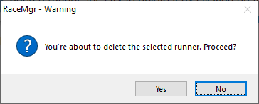

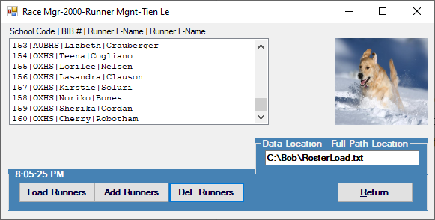

* Click **[Return]** to return to the main menu frmRM0000
* This time when you return to frmRM0000, you should be able to see that **[3 - Time Mgr]** is now enabled. Click on it to proceed to the next step.

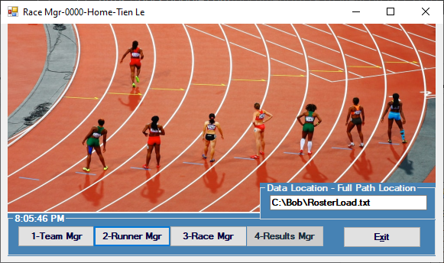

## Step 5: Accessing the time files

* The form frmRM3000 opens up with the following objects
  + Three blank list boxes
  + A text box containing the same file path in frmRM0000, however, with the file changed to “TimeFile.txt.
    - The path should appear as “**C:\Bob\TimeFiles.txt**”
  + Four functional buttons
    - Load Times **[Load Times]**
    - Enter BIB numbers one by one **[Enter BIB #s]**
    - Sync the times with BIB numbers **[Sync]** 
      * This button is disabled at the moment.
    - Enter BIB from an existing text file **[Enter BIB from C:\Bob\BIBPositions.txt]**
  + A return button on the bottom right of the form

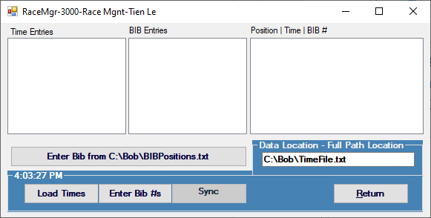

* Let’s start by adding the times. Click **[Load Times]** to load in the times from the file path. The program will input blanks if you do not have the right text file in the correct file path. Please double check if the program doesn’t show anything in the list box.

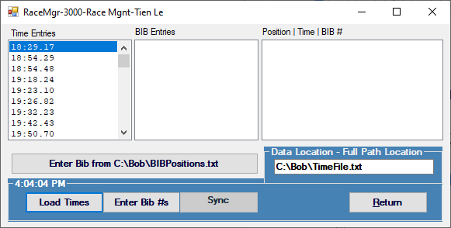

* For the next mini step, you have two options

1. Using **[Enter BIB #s]**, enter each BIB number one by one.

* This gets tedious quickly, and if you made a mistake you can’t go back and change it.
* Because this is an input box, when the user clicks **[Cancel]** *it does not end the input procedure. The cancel button returns an empty string and therefore the program accepts the string as it and keeps on asking for the next BIB number. You can not input a duplicating value.*

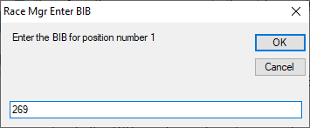

1. Using **[Enter BIB from C:\Bob\BIBPositions.txt]**, enter BIB numbers through a text file. *The author recommends using this method.*

* The program loads the BIB numbers of each runner based on their positions within the text file. If a runner comes first, his or her BIB number will appear at the top, and so on for the second, third…
* Using this method will give you room to change inputs from the text file itself and you don’t have to input each one by hand.

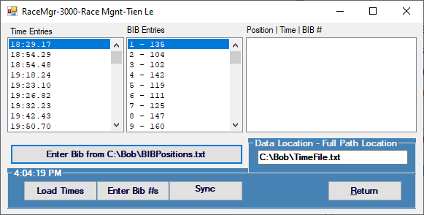

* After you’ve input all the BIB numbers, **[Sync]** button will be enabled. Click the **[Sync]** button and sync the time with the corresponding BIB numbers. For each BIB number the program will find the correct runner and show it in the third list box. You can see the full list of runner placements after it’s done syncing.

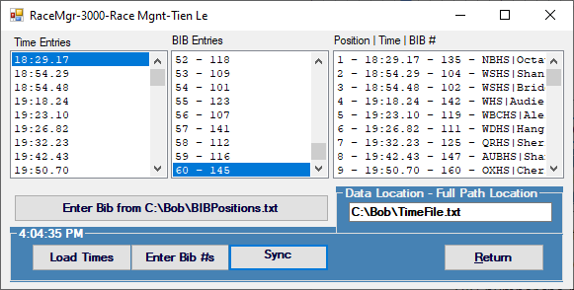

* Click **[Return]** to return to the main menu frmRM0000.
* This time when you return to frmRM0000, you should be able to see that **[4 - Result Mgr]** is now enabled. Click on it to proceed to the next step.

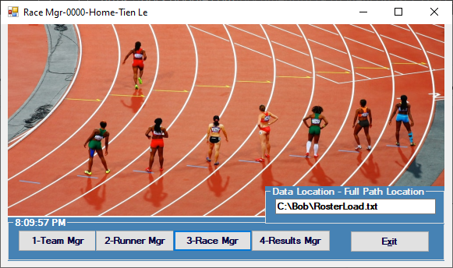

## Step 6: Seeing the results

* The form frmRM4000 opens up with the following objects
  + A blank list boxes
  + Two functional buttons
    - Calculate the results **[Calculate Res.]**
    - Archive the displayed result **[Archive Files]**
  + A return button on the bottom right of the form

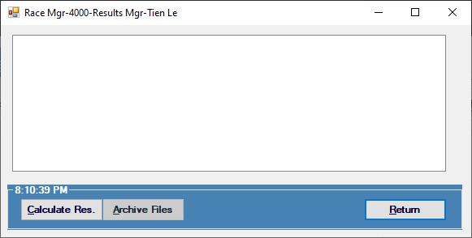

* Click **[Calculate Res.]**. The program will print out a well formatted result of the race including but not limited to:
  + Name of the author and the general date and time
  + Team results
  + Individuals results
* The team results and individuals results are sorted from the best points and the best placements respectively.

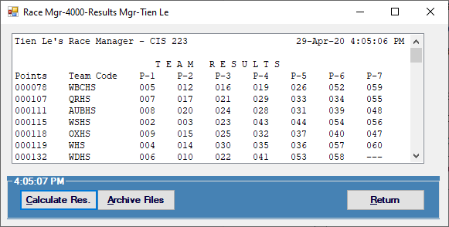

* Click **[Archive Files]** to archive displayed results. You can find the file at “**C:\Bob\RaceMgr-Result_TienLe.txt**”

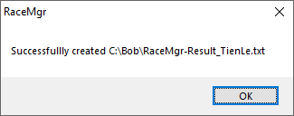

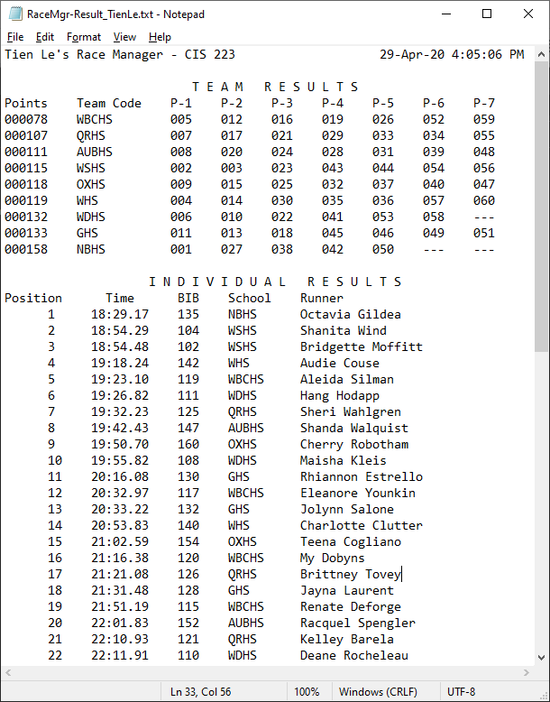

* Click **[Return]** to return to the main menu frmRM0000
* Click **[Exit]** to exit the program.

# Appendix A - Design documentations

## Appendix A.1 - frmRMSplash.vb

### Requirements documents

|  |  |
| --- | --- |
| **Date:**  **Date Submitted:**  **Application Title:**  **Purpose:**  **Program Procedures:**  **Algorithms, Processing, and Conditions:**  **Notes and Restrictions:**  **Comments:** | 25 April, 2020  8 May, 2020  Race Manager - frmRMSplash.vb  frmRMSplash.vb show the user the splash screen to introduce the user to the program  In a Windows Classic Desktop application, the program shows a picture of a marathon as a splash screen.  1. The user opens the program to display the splash screen  The splash screen lasts for 4 seconds  n/a |

### Use case definition

1. The Windows Classic Desktop application opens with a splash screen which lasts for 4 seconds.

## Appendix A.2 - frmRM0000.vb

### Requirements documents

|  |  |
| --- | --- |
| **Date:**  **Date Submitted:**  **Application Title:**  **Purpose:**  **Program Procedures:**  **Algorithms, Processing, and Conditions:**  **Notes and Restrictions:**  **Comments:** | 25 April, 2020  8 May, 2020  Race Manager - frmRM0000.vb  frmRM0000.vb show the user the main menu with the options to choose **[1 - Team Mgr]**, **[2 - Runners Mgr]**, **[3 - Time Mgr]** and **[4 - Results Mgr]**. There’s also a **[Exit]** button  In a Windows Classic Desktop application, the program shows the user the option to pick between Team Manager, Runners Manager, Time Manager and Result Manager.  1. The form appears with 4 options for choose from.  2. The user can choose **[1 - Team Mgr]** to go frmRM1000.vb  3. The user can choose **[2 - Runners Mgr]** to go frmRM2000.vb  4. The user can choose **[3 - Time Mgr]** to go frmRM3000.vb  5. The user can choose **[4 - Results Mgr]** to go frmRM4000.vb  6. The user can change the file path if desired  7. The user can choose Exit to exit the program  - **[3 - Time Mgr]** button should not be enabled until frmRM1000 and frmRM2000 have been filled out  - **[4 - Results Mgr]** button should not be enabled until frmRM3000 has been filled out  n/a |

### Use case definition

1. The Windows Classic Desktop application opens with a blank list box, a text box containing the file path, four functional buttons, and an exit button.
2. The form appears with 4 options to choose from.
3. The user can choose **[1 - Team Mgr]** to go frmRM1000.vb
4. The user can choose **[2 - Runners Mgr]** to go frmRM2000.vb
5. The user can choose **[3 - Time Mgr]** to go frmRM3000.vb
6. The user can choose **[4 - Results Mgr]** to go frmRM4000.vb
7. The user can change the file path if desired
8. The user can repeat step 2 to 7.
9. The user can choose Exit to exit the program

## Appendix A.3 - frmRM1000.vb

### Requirements documents

|  |  |
| --- | --- |
| **Date:**  **Date Submitted:**  **Application Title:**  **Purpose:**  **Program Procedures:**  **Algorithms, Processing, and Conditions:**  **Notes and Restrictions:**  **Comments:** | 25 April, 2020  8 May, 2020  Race Manager - frmRM1000.vb  frmRM1000.vb show the user the main menu with the options to choose **[Load Teams]**, **[Add Teams]**, and **[Delete Teams]**. There’s also a **[Return]** button.  In a Windows Classic Desktop application, the program shows the user the option to load in the teams, add more teams, and delete a team.  1. The user can choose **[Load Teams]** to load in the teams from the file in path file  2. The user can choose **[Add Teams]** to add in a team that they want to.  3. The user can choose **[Delete Teams]** to delete a selected team.  4. The user can change the file path to the text file if desired.  5. The user can choose **[Return]** to return to frmRM0000  n/a  Note: Because the author used an input box, when the user clicks **[Cancel]** *it does not end the input procedure. The cancel button returns an empty string and therefore the program accepts the string as it and keeps on asking for the next information on the list above. You can not input a duplicating value.* |

### Use case definition

1. The Windows Classic Desktop application opens with a blank list box, a text box containing the file path, three functional buttons, and an exit button.
2. The form appears with 3 options to choose from.
3. The user can choose **[Load Teams]** to load in the teams from the file in path file
4. The user can choose **[Add Teams]** to add in a team that they want to.
5. The user can choose **[Delete Teams]** to delete a selected team.
6. The user can change the file path to the text file if desired.
7. The user can repeat step 2 to 6.
8. The user can choose **[Return]** to return to frmRM0000

## Appendix A.4 - frmRM2000.vb

### Requirements documents

|  |  |
| --- | --- |
| **Date:**  **Date Submitted:**  **Application Title:**  **Purpose:**  **Program Procedures:**  **Algorithms, Processing, and Conditions:**  **Notes and Restrictions:**  **Comments:** | 25 April, 2020  8 May, 2020  Race Manager - frmRM2000.vb  frmRM2000.vb show the user the main menu with the options to choose **[Load Runners]**, **[Add Runners]**, and **[Delete Runners]**. There’s also a **[Return]** button.  In a Windows Classic Desktop application, the program shows the user the option to load in the runners, add more runners, and delete a runner.  1. The user can choose **[Load Runners]** to load in the runners from the file in path file  2. The user can choose **[Add Runners]** to add in a runner that they want to.  3. The user can choose **[Delete Runners]** to delete a selected runner.  4. The user can change the file path to the text file if desired.  5. The user can choose **[Return]** to return to frmRM0000  n/a  Note: Because the author used an input box, when the user clicks **[Cancel]** *it does not end the input procedure. The cancel button returns an empty string and therefore the program accepts the string as it and keeps on asking for the next information on the list above. You can not input a duplicating value.* |

### Use case definition

1. The Windows Classic Desktop application opens with a blank list box, a text box containing the file path, three functional buttons, and an exit button.
2. The form appears with 3 options to choose from.
3. The user can choose **[Load Runners]** to load in the runners from the file in path file
4. The user can choose **[Add Runners]** to add in a runner that they want to.
5. The user can choose **[Delete Runners]** to delete a selected runner.
6. The user can change the file path to the text file if desired.
7. The user can repeat step 2 to 6.
8. The user can choose **[Return]** to return to frmRM0000

## Appendix A.5 - frmRM3000.vb

### Requirements documents

|  |  |
| --- | --- |
| **Date:**  **Date Submitted:**  **Application Title:**  **Purpose:**  **Program Procedures:**  **Algorithms, Processing, and Conditions:**  **Notes and Restrictions:**  **Comments:** | 25 April, 2020  8 May, 2020  Race Manager - frmRM3000.vb  frmRM3000.vb show the user the main menu with the options to choose **[Load Time]**, **[Enter BIB #s]**, **[Enter Bib from C:\Bob\BIBPositions.txt]** and **[Sync]**. There’s also a **[Return]** button.  In a Windows Classic Desktop application, the program shows the user the option to load in the time, enter BIB number one by one, enter BIB number through a text file, and sync the BIB numbers with the time.  1. The user can choose **[Load Time]** to load in the time from the file in path file  2. The user can choose **[Enter BIB #s]** to enter BIB number one by one.  3. The user can choose **[Enter Bib from C:\Bob\BIBPositions.txt]** to input BIB number from a text file  4. The user can choose **[Sync]** to sync the time and the BIB numbers  5. The user can change the file path to the text file if desired.  6. The user can choose **[Return]** to return to frmRM0000  **- [Sync]** button should not be enabled until the user has input the time and the BIB numbers.  Note: Because the author used an input box, when the user clicks **[Cancel]** *it does not end the input procedure. The cancel button returns an empty string and therefore the program accepts the string as it and keeps on asking for the next information on the list above. You can not input a duplicating value.* |

### Use case definition

1. The Windows Classic Desktop application opens with three list boxes, four buttons to load in the time, enter BIB number one by one, enter BIB number through a text file, and sync the BIB numbers with the time. There’s also a text box containing file path and a return button.
2. The user can choose **[Load Time]** to load in the time from the file in path file
3. The user can choose **[Enter BIB #s]** to enter BIB number one by one.
4. The user can choose **[Enter Bib from C:\Bob\BIBPositions.txt]** to input BIB number from a text file
5. The user can choose **[Sync]** to sync the time and the BIB numbers
6. The user can change the file path to the text file if desired.
7. The user can repeat step 2 to 7.
8. The user can choose **[Return]** to return to frmRM0000

## Appendix A.6 - frmRM4000.vb

### Requirements documents

|  |  |
| --- | --- |
| **Date:**  **Date Submitted:**  **Application Title:**  **Purpose:**  **Program Procedures:**  **Algorithms, Processing, and Conditions:**  **Notes and Restrictions:**  **Comments:** | 25 April, 2020  8 May, 2020  Race Manager - frmRM4000.vb  frmRM4000.vb show the user the main menu with the options to choose **[Calculate Res.]** and **[Archive Results]**. There’s also a **[Return]** button.  In a Windows Classic Desktop application, the program shows the user the option to calculate the results and the ability to archive the results. There’s also a return button.  1. The user can choose **[Calculate Res.]** to calculate the results and display it in the list box.  2. The user can choose **[Archive Result]** to output the results as a text file located in **C:\Bob\RaceMgr-Result_TienLe**  3. The user can choose **[Return]** to return to frmRM0000  **- [Archive Results]** button should not be enabled until the user has clicked **[Calculate Res.]**  n/a |

### Use case definition

1. The Windows Classic Desktop application opens with a list box, two buttons to calculate the results and archive the results. There are also a return button
2. The form appears with 2 options to choose from.
3. The user can choose **[Calculate Res.]** to calculate the results and display it in the list box.
4. The user can choose **[Archive Result]** to output the results as a text file located in **C:\Bob\RaceMgr-Result_TienLe**
5. The user can choose **[Return]** to return to frmRM0000
6. The user can repeat step 2 to 5.
7. The user can choose **[Return]** to return to frmRM0000

# Appendix B - Test results

## Appendix B.1 - The short version

### frmRMSplash [Splash Form]

### 

### 

### frmRM0000 [Main Menu]

### 

### frmRM1000 [Team Management]

### 

#### 

#### frmRM1000 - [Load Teams]

#### 

#### 

#### frmRM1000 - [Add Teams]

#### 

#### 

#### 

#### 

#### 

#### 

#### 

#### frmRM1000 - [Delete Teams]

#### 

#### 

### frmRM2000 [Runners Management]

### 

#### 

#### frmRM2000 - [Load Runners]

#### 

#### frmRM2000 - [Add Runners]

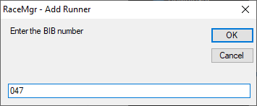

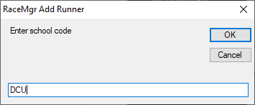

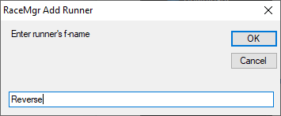

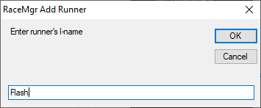

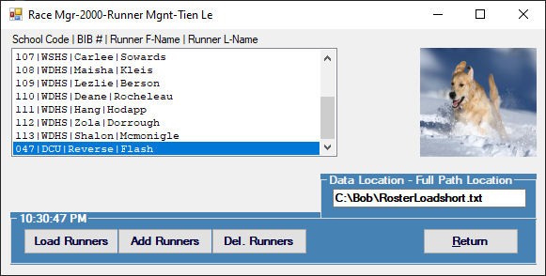

#### frmRM2000 - [Del. Runners]

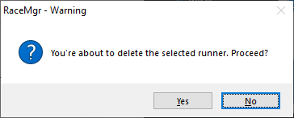

### frmRM3000 [Time Management]

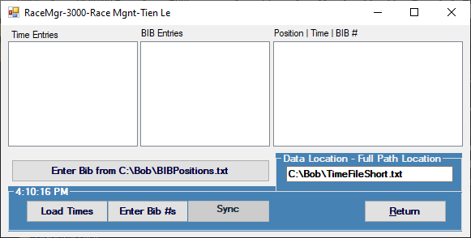

#### frmRM3000 - [Load Times]

#### 

#### frmRM3000 - [Enter BIB #s]

#### 

#### 

#### frmRM3000 - [Sync]

#### 

### frmRM4000 [Results Management]

### 

#### 

#### frmRM4000 - [Calculate Res.]

#### 

#### frmRM4000 - [Archive File]

#### 

#### 

#### Sample Text File Output File

#### 

## Appendix B.2 - The full version

### frmRMSplash [Splash Form]

### 

### 

### frmRM0000 [Main Menu]

### 

### frmRM1000 [Team Management]

### 

#### 

#### frmRM1000 - [Load Teams]

#### 

#### frmRM1000 - [Add Teams]

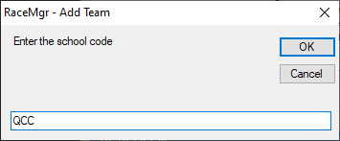

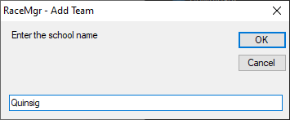

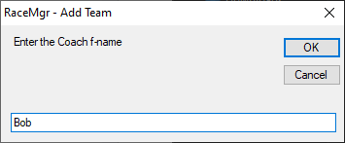

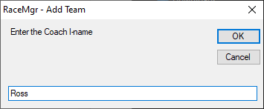

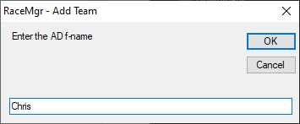

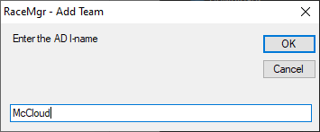

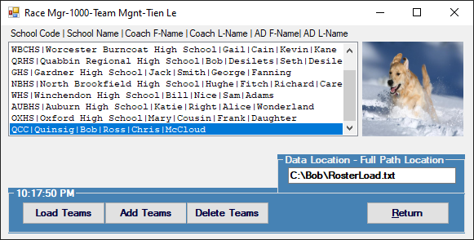

### frmRM1000 - [Delete Teams]

#### 

#### 

### 

### frmRM2000 [Runners Management]

### 

#### frmRM2000 - [Load Runners]

#### 

#### 

#### frmRM2000 - [Add Runners]

#### 

#### 

#### 

#### 

#### 

#### frmRM2000 - [Del. Runners]

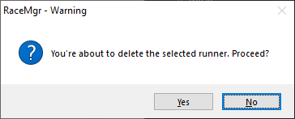

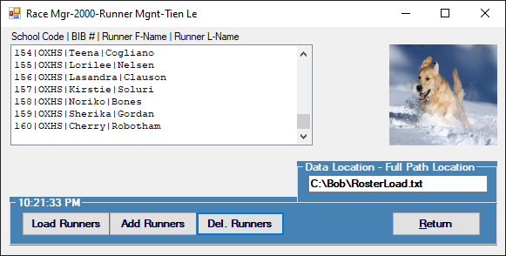

### frmRM3000 [Time Management]

### 

#### frmRM3000 - [Load Times]

#### 

#### 

#### frmRM3000 - [Enter BIB from C:\Bob\BIBPositions.txt]

#### 

#### frmRM3000 - [Sync]

#### 

### 

### frmRM4000 [Results Management]

### 

#### frmRM4000 - [Calculate Res.]

#### 

#### 

#### frmRM4000 - [Archive File]

#### 

#### Sample Text File Output File

#### 

# Appendix C - The source code

## Appendix C.1 - frmRMSplash.vb

*There is no code for this form*

## Appendix C.2 - frmRM0000.vb

Public Class frmRM0000

' Shell Author: Bob Desilets

' Modified by: Tien Le

' Module name: frmRM0000

' Last Modified date: 25-April-2020

' Module description: form 0000 main menu

Private Sub Timer1_Tick(ByVal sender As System.Object, ByVal e As System.EventArgs) Handles Timer1.Tick

grpCommand.Text = TimeOfDay

frmRM1000.grpCommand.Text = TimeOfDay

frmRM2000.grpCommand.Text = TimeOfDay

frmRM3000.grpCommand.Text = TimeOfDay

frmRM4000.grpCommand.Text = TimeOfDay

End Sub

Private Sub btnTeamMgr_Click(ByVal sender As System.Object, ByVal e As System.EventArgs) Handles btnTeamMgr.Click

frmRM1000.Show()

Me.Hide()

End Sub

Private Sub btnRunnerMgr_Click(ByVal sender As System.Object, ByVal e As System.EventArgs) Handles btnRunnerMgr.Click

frmRM2000.Show()

Me.Hide()

End Sub

Private Sub btnRaceMgr_Click(ByVal sender As System.Object, ByVal e As System.EventArgs) Handles btnRaceMgr.Click

frmRM3000.Show()

Me.Hide()

End Sub

Private Sub btnResultsMgr_Click(ByVal sender As System.Object, ByVal e As System.EventArgs) Handles btnResultsMgr.Click

frmRM4000.Show()

Me.Hide()

End Sub

Private Sub btnExit_Click(ByVal sender As System.Object, ByVal e As System.EventArgs) Handles btnExit.Click

Me.Close()

End Sub

End Class

## Appendix C.3 - frmRM1000.vb

Imports System.IO

' Shell Author: Bob Desilets

' Modified by: Tien Le

' Module name: frmRM1000

' Last Modified date: 25-April-2020

' Module description: form 1000 team mgr

Public Class frmRM1000

Private Sub btnLoadTeams_Click(ByVal sender As System.Object, ByVal e As System.EventArgs) Handles btnLoadTeam.Click

' This routine loads the lstTeam box from an ASCII .txt file

' # School [School Code | Name | Coach F-Name| Coach L-Name | AD F-Name | AD L-Name]

Dim strRow As String

Dim bolFoundCode As Boolean = False

Dim bolEndCode As Boolean = False

Dim bolFoundDup As Boolean = False

Dim intPosition As Integer

Dim intPosition2 As Integer

Dim strTeamCodeIn As String

Dim textIn As StreamReader =

New StreamReader(New FileStream(txtFilePath.Text, FileMode.OpenOrCreate, FileAccess.Read))

' Clear Team listbox

lstTeam.Items.Clear()

Do While textIn.Peek <> -1 And Not bolEndCode

Me.Refresh()

strRow = textIn.ReadLine.Trim

If Not bolFoundCode Then

If "# SCHOOL " = UCase(Mid(strRow, 1, 9)) Then

bolFoundCode = True

End If

Else

If Mid(strRow, 1, 2) <> "# " Then

For Each item As String In lstTeam.Items

intPosition = InStr(1, strRow, "|")

strTeamCodeIn = Mid(strRow, 1, intPosition - 1)

intPosition2 = InStr(1, item, strTeamCodeIn)

If intPosition2 > 0 Then

bolFoundDup = True

MsgBox("Found Duplicate School Code: " & strTeamCodeIn)

End If

Next

If Not bolFoundDup Then

lstTeam.Items.Add(strRow)

Else

lstTeam.Items.Add("DUPLICATE School Code: " & strRow)

lstTeam.Items.Add("Please correct input file and reload teams")

bolEndCode = True

End If

Else

bolEndCode = True

End If

End If

Loop

'Set focus on the first item

lstTeam.SelectedIndex = 0

End Sub

Private Sub BtnAddRunners_Click(sender As Object, e As EventArgs) Handles btnAddRunners.Click

'Adding team one by one so I don't have to make a new form :)

Dim intPosition As Integer

Dim strTeamCodeIn As String

Dim bolFoundDup As Boolean = False

Dim bolEndCode As Boolean = False

Dim strSchool_Code As String = UCase(InputBox("Enter the school code", "RaceMgr - Add Team"))

Do While Not bolFoundDup And Not bolEndCode

For Each item As String In lstTeam.Items

intPosition = InStr(1, item, "|")

strTeamCodeIn = Mid(item, 1, intPosition - 1)

If strTeamCodeIn = strSchool_Code Then

bolFoundDup = True

MsgBox("Found Duplicate School Code: " & strTeamCodeIn)

End If

Next

If bolFoundDup Then

strSchool_Code = UCase(InputBox("Enter a different school code", "RaceMgr - Add Team"))

bolFoundDup = False

Else

bolEndCode = True

End If

Loop

Dim strSchool_Name As String = InputBox("Enter the school name", "RaceMgr - Add Team")

Dim strSchool_CoachFname As String = InputBox("Enter the Coach f-name", "RaceMgr - Add Team")

Dim strSchool_CoachLname As String = InputBox("Enter the Coach l-name", "RaceMgr - Add Team")

Dim strSchool_ADFname As String = InputBox("Enter the AD f-name", "RaceMgr - Add Team")

Dim strSchool_ADLname As String = InputBox("Enter the AD l-name", "RaceMgr - Add Team")

'Print to list box

lstTeam.Items.Add(strSchool_Code & "|" & strSchool_Name & "|" & strSchool_CoachFname & "|" & strSchool_CoachLname & "|" & strSchool_ADFname & "|" & strSchool_ADLname)

End Sub

Private Sub btnDeleteRunner_Click(ByVal sender As System.Object, ByVal e As System.EventArgs) Handles btnDeleteRunner.Click

'This routine removes a Team from the list based on the entered Team Code

Dim answer As Integer

answer = MsgBox("You're about to delete the selected team. Proceed?", vbQuestion + vbYesNo + vbDefaultButton2, "RaceMgr - Warning")

If answer = vbYes Then

'Remove the team from the list

lstTeam.Items.Remove(lstTeam.SelectedItem)

End If

End Sub

Private Sub btnExit_Click(ByVal sender As System.Object, ByVal e As System.EventArgs) Handles btnExit.Click

If lstTeam.Items.Count > 0 And frmRM2000.lstPlayers.Items.Count > 0 Then

frmRM0000.btnRaceMgr.Enabled = True

Else

frmRM0000.btnRaceMgr.Enabled = False

End If

frmRM0000.Show()

Me.Hide()

End Sub

Private Sub frmRM1000_Load(ByVal sender As System.Object, ByVal e As System.EventArgs) Handles MyBase.Load

If txtFilePath.Text.Trim = "" Then

txtFilePath.Text = frmRM0000.txtFilePath.Text

End If

End Sub

Private Sub frmRM1000_VisibleChanged(ByVal sender As Object, ByVal e As System.EventArgs) Handles Me.VisibleChanged

If txtFilePath.Text.Trim = "" Then

txtFilePath.Text = frmRM0000.txtFilePath.Text

End If

End Sub

End Class

## Appendix C.4 - frmRM2000.vb

Imports System.IO

' Shell Author: Bob Desilets

' Modified by: Tien Le

' Module name: frmRM2000

' Last Modified date: 25-April-2020

' Module description: form 2000 runner mgr

Public Class frmRM2000

Private Sub btnLoadRunners_Click(ByVal sender As System.Object, ByVal e As System.EventArgs) Handles btnLoadRunners.Click

' This routine loads the lstRunner box from an ASCII .txt file

Dim strRow As String

Dim bolFoundCode As Boolean = False

Dim bolEndCode As Boolean = False

Dim bolFoundDup As Boolean = False

Dim intPosition As Integer

Dim intPosition2 As Integer

Dim strTeamCodeIn As String

Dim textIn As StreamReader = New StreamReader(New FileStream(txtFilePath.Text, FileMode.OpenOrCreate, FileAccess.Read))

' Clear Team listbox

lstPlayers.Items.Clear()

Do While textIn.Peek <> -1 And Not bolEndCode

Me.Refresh()

strRow = textIn.ReadLine.Trim

If Not bolFoundCode Then

If "# ROSTER " = UCase(Mid(strRow, 1, 9)) Then

bolFoundCode = True

End If

Else

If Mid(strRow, 1, 2) <> "# " Then

For Each item As String In lstPlayers.Items

intPosition = InStr(1, strRow, "|")

strTeamCodeIn = Mid(strRow, 1, intPosition - 1)

intPosition2 = InStr(1, item, strTeamCodeIn)

If intPosition2 > 0 Then

bolFoundDup = True

MsgBox("Found Duplicate runners BIB: " & strTeamCodeIn)

End If

Next

If Not bolFoundDup Then

lstPlayers.Items.Add(strRow)

Else

lstPlayers.Items.Add("DUPLICATE runners BIB: " & strRow)

lstPlayers.Items.Add("Please correct input file and reload teams")

bolEndCode = True

End If

Else

bolEndCode = True

End If

End If

Loop

'Set focus on the first item

lstPlayers.SelectedIndex = 0

End Sub

Private Sub btnAddRunners_Click(ByVal sender As System.Object, ByVal e As System.EventArgs) Handles btnAddRunners.Click

' This routine loops through a msg box prompting the user for Bib # | School Code | Name

' You must scan the existing runner's Bib #s for duplicates... Force the user

' to enter a new number

Dim bolDup As Boolean

Dim strBIB_Input As String = InputBox("Enter the BIB number", "RaceMgr - Add Runner")

Do

bolDup = False

For Each strBIB_Test As String In lstPlayers.Items

If Equals(Mid(strBIB_Test, 1, 3), strBIB_Input) Then

bolDup = True

End If

Next

If Not bolDup Then

Dim strRoster_BIB As String = strBIB_Input

Dim strRoster_SchoolCode As String = UCase(InputBox("Enter school code", "RaceMgr Add Runner"))

Dim strRoster_RunnerFname As String = InputBox("Enter runner's f-name", "RaceMgr Add Runner")

Dim strRoster_RunnerLname As String = InputBox("Enter runner's l-name", "RaceMgr Add Runner")

lstPlayers.Items.Add(strRoster_BIB & "|" & strRoster_SchoolCode & "|" & strRoster_RunnerFname & "|" & strRoster_RunnerLname)

Else

strBIB_Input = InputBox("BIB number exist. Please enter a different BIB number", "RaceMgr - Add Runner")

End If

Loop While bolDup

End Sub

Private Sub btnDeleteRunner_Click(ByVal sender As System.Object, ByVal e As System.EventArgs) Handles btnDeleteRunner.Click

'This routine removes a runner from the list based on the entered Bib #... Perform typical validation...

Dim answer As Integer

answer = MsgBox("You're about to delete the selected runner. Proceed?", vbQuestion + vbYesNo + vbDefaultButton2, "RaceMgr - Warning")

If answer = vbYes Then

'Remove the team from the list

lstPlayers.Items.Remove(lstPlayers.SelectedItem)

End If

End Sub

Private Sub btnExit_Click(ByVal sender As System.Object, ByVal e As System.EventArgs) Handles btnExit.Click

If frmRM1000.lstTeam.Items.Count > 0 And lstPlayers.Items.Count > 0 Then

frmRM0000.btnRaceMgr.Enabled = True

Else

frmRM0000.btnRaceMgr.Enabled = False

End If

frmRM0000.Show()

Me.Hide()

End Sub

Private Sub frmRM2000_Load(ByVal sender As System.Object, ByVal e As System.EventArgs) Handles MyBase.Load

If txtFilePath.Text.Trim = "" Then

txtFilePath.Text = frmRM0000.txtFilePath.Text

End If

End Sub

Private Sub frmRM2000_VisibleChanged(ByVal sender As Object, ByVal e As System.EventArgs) Handles Me.VisibleChanged

If txtFilePath.Text.Trim = "" Then

txtFilePath.Text = frmRM0000.txtFilePath.Text

End If

End Sub

End Class

## 

## Appendix C.5 - frmRM3000.vb

Imports System.IO

' Shell Author: Bob Desilets

' Modified by: Tien Le

' Module name: frmRM3000

' Last Modified date: 25-April-2020

' Module description: form 3000 time mgr

Public Class frmRM3000

Private Sub btnExit_Click(ByVal sender As System.Object, ByVal e As System.EventArgs) Handles btnExit.Click

If lstSyncTimeBibs.Items.Count > 0 Then

frmRM0000.btnResultsMgr.Enabled = True

Else

frmRM0000.btnResultsMgr.Enabled = False

End If

frmRM0000.Show()

Me.Hide()

End Sub

Private Sub btnSyncTimesBibs_Click(ByVal sender As System.Object, ByVal e As System.EventArgs) Handles btnSyncTimesBibs.Click

' This button is disabled until both Times and Bibs have been entered.

' The associated list box is invisible until this buttom is pressed

' This routine merges Position | Time | Bib #

Dim intPostion As Integer

Dim index As Integer = 0

Dim intPlacing As Integer = 1

lstSyncTimeBibs.Items.Clear()

For Each item As String In lstTimeEntry.Items

Dim strRunner As String = "Runner Not Found"

Dim strSchool As String = "School Not Found"

lstBibs.SelectedIndex = index

intPostion = InStr(lstBibs.SelectedItem, "- ")

strRunner = Trim(Mid(lstBibs.SelectedItem, intPostion + 2))

' Find School and Runners by stepping through lstPlayers

For Each item2 As String In frmRM2000.lstPlayers.Items

' Sample row layout -- lstRoster.Items.Add("A-SHS")

If strRunner = Mid(item2, 1, 3) Then

strSchool = Mid(item2, 5)

End If

Next

lstSyncTimeBibs.Items.Add(intPlacing & " - " & item & " - " & strRunner & " - " & strSchool)

index += 1

intPlacing += 1

Me.Refresh()

Next

End Sub

Private Sub btnEnterResults_Click(ByVal sender As System.Object, ByVal e As System.EventArgs) Handles btnEnterResults.Click

'Load time button

Dim textIn As StreamReader = New StreamReader(New FileStream(txtFilePath.Text, FileMode.OpenOrCreate, FileAccess.Read))

Dim strRow As String

Dim bolFoundCode As Boolean = False

'Clear Team listbox

lstTimeEntry.Items.Clear()

Do While textIn.Peek <> -1

Me.Refresh()

strRow = textIn.ReadLine.Trim

If Not bolFoundCode Then

If "# TIME FILE" = UCase(Mid(strRow, 1, 11)) Then

bolFoundCode = True

End If

Else

If Mid(strRow, 1, 2) <> "# " Then

lstTimeEntry.Items.Add(strRow)

End If

End If

Loop

'Set focus on the first item

lstTimeEntry.SelectedIndex = 0

'Check if it's sync-able

If lstTimeEntry.Items.Count > 0 And lstBibs.Items.Count > 0 Then

btnSyncTimesBibs.Enabled = True

Else

btnSyncTimesBibs.Enabled = False

End If

End Sub

Private Sub txtFilePath_TextChanged(ByVal sender As System.Object, ByVal e As System.EventArgs) Handles txtFilePath.TextChanged

If txtFilePath.Text.Length > 0 Then

btnEnterResults.Enabled = True

Else

btnEnterResults.Enabled = False

End If

End Sub

Private Sub btnEnterBib_Click(ByVal sender As System.Object, ByVal e As System.EventArgs) Handles btnEnterBib.Click

'Enter Bib one by one.

Dim strInput As String

Dim bolDup As Boolean

Dim intStart As Integer

Dim strTest As String

'Clear Bib list

lstBibs.Items.Clear()

For index As Integer = 1 To lstTimeEntry.Items.Count

strInput = InputBox("Enter the BIB for position #" & index, "Race Mgr Enter BIB")

Do

bolDup = False

For Each strBIB_Test As String In lstBibs.Items

intStart = InStr(1, strBIB_Test, "-")

strTest = Mid(strBIB_Test, intStart + 2, 3)

'lstBibs.Items.Add(strTest)

If strTest = strInput Then

bolDup = True

End If

Next

If Not bolDup Then

lstBibs.Items.Add(index & " - " & strInput)

Else

strInput = InputBox("Enter a different BIB for position number " & index, "Race Mgr Enter BIB")

End If

Loop While bolDup

Next

'Set focus on the first item

lstBibs.SelectedIndex = 0

'Check if it's sync-able

If lstTimeEntry.Items.Count > 0 And lstBibs.Items.Count > 0 Then

btnSyncTimesBibs.Enabled = True

Else

btnSyncTimesBibs.Enabled = False

End If

End Sub

Private Sub BtnBibAuto_Click(sender As Object, e As EventArgs) Handles btnBibAuto.Click

Dim strPath As String = "C:\Bob\BIBPositions.txt"

Dim strRow As String

Dim bolFoundCode As Boolean = False

Dim intCounter As Integer = 1

Dim intStart As Integer

Dim strTest As String

Dim arrCheck(10000) As String

Dim index As Integer = 0

Dim textIn As StreamReader = New StreamReader(New FileStream(strPath, FileMode.OpenOrCreate, FileAccess.Read))

Do While textIn.Peek <> -1

Me.Refresh()

strRow = textIn.ReadLine.Trim

arrCheck(index) = Mid(strRow, 1, 3)

index += 1

Loop

Dim numCheck As Integer = 0

For i As Integer = 0 To arrCheck.Length - 1

If Not arrCheck(i) Is Nothing Then

Dim l As Integer = Array.LastIndexOf(arrCheck, arrCheck(i))

If l <> i Then

numCheck += 1

End If

End If

Next

Dim textIn2 As StreamReader = New StreamReader(New FileStream(strPath, FileMode.OpenOrCreate, FileAccess.Read))

If numCheck <> 0 Then

lstBibs.Items.Clear()

lstBibs.Items.Add("FOUND DUPLICATE")

lstBibs.Items.Add("PLEASE FIX INPUT FILE")

Else

'Add all lines to lstbox

Do While textIn2.Peek <> -1

Me.Refresh()

strRow = textIn2.ReadLine.Trim

lstBibs.Items.Add(intCounter & " - " & Mid(strRow, 1, 3))

intCounter += 1

Loop

End If

'Set focus on the first item

lstBibs.SelectedIndex = 0

'Check if it's sync-able

If lstTimeEntry.Items.Count > 0 And lstBibs.Items.Count > 0 Then

btnSyncTimesBibs.Enabled = True

Else

btnSyncTimesBibs.Enabled = False

End If

End Sub

End Class

## 

## Appendix C.6 - frmRM4000.vb

Imports System.IO

' Shell Author: Bob Desilets

' Modified by: Tien Le

' Module name: frmRM4000

' Last Modified date: 25-April-2020

' Module description: form 4000 result mgr

Public Class frmRM4000

Private Sub btnExit_Click(ByVal sender As System.Object, ByVal e As System.EventArgs) Handles btnExit.Click

frmRM0000.Show()

Me.Hide()

End Sub

Private Sub btnCalculateResults_Click(ByVal sender As System.Object, ByVal e As System.EventArgs) Handles btnCalculateResults.Click

'Calculate the result

'Enable the Archive button

btnArchive.Enabled = True

'Clear the list box

lstTeamResults.Items.Clear()

Dim strDayTime As String = Format(Now, "General Date")

Dim strFullName As String = "Tien Le's Race Manager - CIS 223"

Dim strOneTab As String = " "

Dim strFiveTab As String = " "

Dim strResultLine As String

Dim index As Integer = 0

Dim intPositionStart As Integer

Dim intPositionEnd As Integer

Dim intPostitionTest As Integer

Dim intPoints(7) As Integer

Dim intTotalPoints As Integer = 0

Dim strPosition As String

Dim strTime As String

Dim strBIB As String

Dim strSchool As String

Dim strRunnerFname As String

Dim strRunnerLname As String

For Each str1000_item As String In frmRM1000.lstTeam.Items

'Outer loop

Dim str1000_SchoolCode As String = Trim(Mid(str1000_item, 1, InStr(1, str1000_item, "|") - 1))

For Each str3000_item As String In frmRM3000.lstSyncTimeBibs.Items

'Inner loop

'Find the vertical bar

intPositionEnd = InStr(1, str3000_item, "|")

'Find the 3rd (-) sign

intPositionStart = InStr(1, str3000_item, "-")

intPostitionTest = InStr(intPositionStart + 1, str3000_item, "-")

intPositionStart = InStr(intPostitionTest + 1, str3000_item, "-")

intPositionStart += 2

'Copy the school code from (index) of SYNC listbox

Dim str3000_SchoolCode As String = Trim(Mid(str3000_item, intPositionStart, intPositionEnd - intPositionStart))

'Check for if it's the same school

If str1000_SchoolCode = str3000_SchoolCode Then

'Add point to it if it's the same school

intPoints(index) = Convert.ToInt32(Mid(str3000_item, 1, 2))

If index < 5 Then

intTotalPoints += intPoints(index)

End If

index += 1

End If

Next

'Default spacing

Dim strSpace As String = " "

If str1000_SchoolCode.Trim.Length = 3 Then

strSpace = " "

ElseIf str1000_SchoolCode.Trim.Length = 4 Then

strSpace = " "

ElseIf str1000_SchoolCode.Trim.Length = 5 Then

strSpace = " "

End If

If intTotalPoints > 0 And index = 7 Then

'Seven Runners

strResultLine = $"{intTotalPoints:D6} {str1000_SchoolCode}{strSpace}{intPoints(0):D3} {intPoints(1):D3} {intPoints(2):D3} {intPoints(3):D3} {intPoints(4):D3} {intPoints(5):D3} {intPoints(6):D3}"

lstTeamResults.Items.Add(strResultLine)

End If

If intTotalPoints > 0 And index = 6 Then

'Six Runners

strResultLine = $"{intTotalPoints:D6} {str1000_SchoolCode}{strSpace}{intPoints(0):D3} {intPoints(1):D3} {intPoints(2):D3} {intPoints(3):D3} {intPoints(4):D3} {intPoints(5):D3} ---"

lstTeamResults.Items.Add(strResultLine)

End If

If intTotalPoints > 0 And index = 5 Then

'Five Runners

strResultLine = $"{intTotalPoints:D6} {str1000_SchoolCode}{strSpace}{intPoints(0):D3} {intPoints(1):D3} {intPoints(2):D3} {intPoints(3):D3} {intPoints(4):D3} --- ---"

lstTeamResults.Items.Add(strResultLine)

End If

'Reset index and all values

intTotalPoints = 0

intPoints(0) = 0

intPoints(1) = 0

intPoints(2) = 0

intPoints(3) = 0

intPoints(4) = 0

intPoints(5) = 0

intPoints(6) = 0

index = 0

Next

' Sort all items added previously.

lstTeamResults.Sorted = True

' Stop sorting all items

lstTeamResults.Sorted = False

'Adding the labels

lstTeamResults.Items.Insert(0, strFullName & strFiveTab & strDayTime)

lstTeamResults.Items.Insert(1, "")

lstTeamResults.Items.Insert(2, strFiveTab & " T E A M R E S U L T S")

lstTeamResults.Items.Insert(3, "Points" & strOneTab & "Team Code" & strOneTab & "P-1" & strOneTab & "P-2" &

strOneTab & "P-3" & strOneTab & "P-4" & strOneTab & "P-5" & strOneTab & "P-6" & strOneTab & "P-7")

lstTeamResults.Items.Add("")

lstTeamResults.Items.Add(strFiveTab & "I N D I V I D U A L R E S U L T S")

lstTeamResults.Items.Add("Position" & strOneTab & " Time " & strOneTab &

"BIB" & strOneTab & "School" & strOneTab & "Runner")

'Getting information from frmRM3000 lstSync

For Each str3000_item As String In frmRM3000.lstSyncTimeBibs.Items

intPositionStart = 1

intPositionEnd = InStr(intPositionStart, str3000_item, "-")

strPosition = Mid(str3000_item, intPositionStart, 2)

intPositionStart = intPositionEnd + 2

intPositionEnd = InStr(intPositionStart, str3000_item, "-")

strTime = Mid(str3000_item, intPositionStart, 8)

intPositionStart = intPositionEnd + 2

intPositionEnd = InStr(intPositionStart, str3000_item, "-")

strBIB = Mid(str3000_item, intPositionStart, 3)

intPositionStart = intPositionEnd + 2

intPositionEnd = InStr(intPositionStart, str3000_item, "|")

strSchool = Mid(str3000_item, intPositionStart, intPositionEnd - intPositionStart)

intPositionStart = intPositionEnd + 1

intPositionEnd = InStr(intPositionStart, str3000_item, "|")

strRunnerFname = Mid(str3000_item, intPositionStart, intPositionEnd - intPositionStart)

intPositionStart = intPositionEnd + 1

intPositionEnd = InStr(intPositionStart, str3000_item, "|")

strRunnerLname = Mid(str3000_item, intPositionStart)

'Default spacing

Dim strSpace As String = " "

If strSchool.Trim.Length = 3 Then

strSpace = " "

ElseIf strSchool.Trim.Length = 4 Then

strSpace = " "

ElseIf strSchool.Trim.Length = 5 Then

strSpace = " "

End If

strResultLine = $" {strPosition} {strTime} {strBIB} {strSchool}{strSpace}{strRunnerFname} {strRunnerLname}"

lstTeamResults.Items.Add(strResultLine)

Next

End Sub

Private Sub btnArchive_Click(ByVal sender As System.Object, ByVal e As System.EventArgs) Handles btnArchive.Click

' Create new file.

Dim strPath As String = "C:\Bob\RaceMgr-Result_TienLe.txt"

Using writer As StreamWriter =

New StreamWriter(strPath)

For Each strRow As String In lstTeamResults.Items

writer.WriteLine(strRow)

Next

End Using

MsgBox("Successfullly created C:\Bob\RaceMgr-Result_TienLe.txt")

End Sub

End Class

## 

## Appendix C.7 - RosterLoad.txt

# School [School Code|School Name|Coach F-Name|Coach L-Name|AD F-Name|AD L-Name]

WSHS|Worcester South High School|Glenn|Clauss|Bret|Zane

WDHS|Worcester Dorehty High School|Ellsworth|Quackenbush|Bert|Coco

WBCHS|Worcester Burncoat High School|Gail|Cain|Kevin|Kane

QRHS|Quabbin Regional High School|Bob|Desilets|Seth|Desilets

GHS|Gardner High School|Jack|Smith|George|Fanning

NBHS|North Brookfield High School|Hughe|Fitch|Richard|Carey

WHS|Winchendon High School|Bill|Nice|Sam|Adams

AUBHS|Auburn High School|Katie|Right|Alice|Wonderland

OXHS|Oxford High School|Mary|Cousin|Frank|Daughter

# Roster [Bib|School Code|Runner's F-Name|Runner's L-Name]

101|WSHS|Sanora|Hibshman

102|WSHS|Bridgette|Moffitt

103|WSHS|Karine|Chunn

104|WSHS|Shanita|Wind

105|WSHS|Fernanda|Parsell

106|WSHS|Albertha|Baringer

107|WSHS|Carlee|Sowards

108|WDHS|Maisha|Kleis

109|WDHS|Lezlie|Berson

110|WDHS|Deane|Rocheleau

111|WDHS|Hang|Hodapp

112|WDHS|Zola|Dorrough

113|WDHS|Shalon|Mcmonigle

114|WBCHS|Valentine|Vant

115|WBCHS|Renate|Deforge

116|WBCHS|Yung|Corner

117|WBCHS|Eleanore|Younkin

118|WBCHS|Alexia|Fandel

119|WBCHS|Aleida|Silman

120|WBCHS|My|Dobyns

121|QRHS|Kelley|Barela

122|QRHS|Tatyana|Thornley

123|QRHS|Diedre|Hake

124|QRHS|Krysta|Sweet

125|QRHS|Sheri|Wahlgren

126|QRHS|Brittney|Tovey

127|QRHS|Tuyet|Manfre

128|GHS|Jayna|Laurent

129|GHS|Anastasia|Noles

130|GHS|Rhiannon|Estrello

131|GHS|Katy|Dent

132|GHS|Jolynn|Salone

133|GHS|Johnie|Rasmus

134|GHS|Tashia|Schlick

135|NBHS|Octavia|Gildea

136|NBHS|Charlene|Heredia

137|NBHS|Reina|Tatem

138|NBHS|Dong|Factor

139|NBHS|Jeniffer|Bichrest

140|WHS|Charlotte|Clutter

141|WHS|Alaine|Chowning

142|WHS|Audie|Couse

143|WHS|Madelaine|Lightbody

144|WHS|Nery|Shawl

145|WHS|Milda|Auxier

146|WHS|Beatriz|Embury

147|AUBHS|Shanda|Walquist

148|AUBHS|Felipa|Gillen

149|AUBHS|Kena|Launer

150|AUBHS|Tatum|Hoppe

151|AUBHS|Lura|Mccants

152|AUBHS|Racquel|Spengler

153|AUBHS|Lizbeth|Grauberger

154|OXHS|Teena|Cogliano

155|OXHS|Lorilee|Nelsen

156|OXHS|Lasandra|Clauson

157|OXHS|Kirstie|Soluri

158|OXHS|Noriko|Bones

159|OXHS|Sherika|Gordan

160|OXHS|Cherry|Robotham

## 

## Appendix C.8 - TimeFile.txt

# Time File

18:29.17

18:54.29

18:54.48

19:18.24

19:23.10

19:26.82

19:32.23

19:42.43

19:50.70

19:55.82

20:16.08

20:32.97

20:33.22

20:53.83

21:02.59

21:16.38

21:21.08

21:31.48

21:51.19

22:01.83

22:10.93

22:11.91

22:16.62

22:18.29

22:19.16

22:20.54

22:21.40

22:25.68

22:50.11

22:57.76

23:04.07

23:04.54

23:07.77

23:23.39

23:24.64

23:28.49

23:28.81

23:29.08

23:54.10

23:55.36

24:15.87

24:16.17

24:24.64

24:25.54

24:27.74

24:34.66

24:35.33

24:39.30

25:14.75

25:25.87

25:43.87

26:03.25

26:34.07

26:36.04

26:38.13

26:46.89

27:14.52

27:57.58

28:00.53

28:01.24

## 

## Appendix C.9 - BIBPositions.txt

135|NBHS|Octavia|Gildea

104|WSHS|Shanita|Wind

102|WSHS|Bridgette|Moffitt

142|WHS|Audie|Couse

119|WBCHS|Aleida|Silman

111|WDHS|Hang|Hodapp

125|QRHS|Sheri|Wahlgren

147|AUBHS|Shanda|Walquist

160|OXHS|Cherry|Robotham

108|WDHS|Maisha|Kleis

130|GHS|Rhiannon|Estrello

117|WBCHS|Eleanore|Younkin

132|GHS|Jolynn|Salone

140|WHS|Charlotte|Clutter

154|OXHS|Teena|Cogliano

120|WBCHS|My|Dobyns

126|QRHS|Brittney|Tovey

128|GHS|Jayna|Laurent

115|WBCHS|Renate|Deforge

152|AUBHS|Racquel|Spengler

121|QRHS|Kelley|Barela

110|WDHS|Deane|Rocheleau

103|WSHS|Karine|Chunn

151|AUBHS|Lura|Mccants

158|OXHS|Noriko|Bones

114|WBCHS|Valentine|Vant

139|NBHS|Jeniffer|Bichrest

149|AUBHS|Kena|Launer

122|QRHS|Tatyana|Thornley

146|WHS|Beatriz|Embury

150|AUBHS|Tatum|Hoppe

157|OXHS|Kirstie|Soluri

127|QRHS|Tuyet|Manfre

124|QRHS|Krysta|Sweet

143|WHS|Madelaine|Lightbody

144|WHS|Nery|Shawl

155|OXHS|Lorilee|Nelsen

136|NBHS|Charlene|Heredia

148|AUBHS|Felipa|Gillen

159|OXHS|Sherika|Gordan

113|WDHS|Shalon|Mcmonigle

138|NBHS|Dong|Factor

106|WSHS|Albertha|Baringer

105|WSHS|Fernanda|Parsell

133|GHS|Johnie|Rasmus

134|GHS|Tashia|Schlick

156|OXHS|Lasandra|Clauson

153|AUBHS|Lizbeth|Grauberger

129|GHS|Anastasia|Noles

137|NBHS|Reina|Tatem

131|GHS|Katy|Dent

118|WBCHS|Alexia|Fandel

109|WDHS|Lezlie|Berson

101|WSHS|Sanora|Hibshman

123|QRHS|Diedre|Hake

107|WSHS|Carlee|Sowards

141|WHS|Alaine|Chowning

112|WDHS|Zola|Dorrough

116|WBCHS|Yung|Corner

145|WHS|Milda|Auxier

## 

## Appendix C.10 - RosterLoadshort.txt

# School [School Code|School Name|Coach F-Name|Coach L-Name|AD F-Name|AD L-Name]

WSHS|Worcester South High School|Glenn|Clauss|Bret|Zane

WDHS|Worcester Dorehty High School|Ellsworth|Quackenbush|Bert|Coco

WBCHS|Worcester Burncoat High School|Gail|Cain|Kevin|Kane

QRHS|Quabbin Regional High School|Bob|Desilets|Seth|Desilets

GHS|Gardner High School|Jack|Smith|George|Fanning

NBHS|North Brookfield High School|Hughe|Fitch|Richard|Carey

WHS|Winchendon High School|Bill|Nice|Sam|Adams

AUBHS|Auburn High School|Katie|Right|Alice|Wonderland

OXHS|Oxford High School|Mary|Cousin|Frank|Daughter

# Roster [Bib #|School Code|Runner's F-Name|Runner's L-Name]

101|WSHS|Sanora|Hibshman

102|WSHS|Bridgette|Moffitt

103|WSHS|Karine|Chunn

104|WSHS|Shanita|Wind

105|WSHS|Fernanda|Parsell

106|WSHS|Albertha|Baringer

107|WSHS|Carlee|Sowards

108|WDHS|Maisha|Kleis

109|WDHS|Lezlie|Berson

110|WDHS|Deane|Rocheleau

111|WDHS|Hang|Hodapp

112|WDHS|Zola|Dorrough

113|WDHS|Shalon|Mcmonigle

## 

## Appendix C.11 - TimeFileshort.txt

# Time File

18:29.17

18:54.29

18:54.48

19:18.24

19:23.10

19:26.82

19:32.23

19:42.43

19:50.70

19:55.82

20:16.08

20:32.97

20:33.22

## Appendix C.12 - RaceMgr-Result_TienLe.txt

Tien Le's Race Manager - CIS 223 29-Apr-20 3:54:35 PM

T E A M R E S U L T S

Points Team Code P-1 P-2 P-3 P-4 P-5 P-6 P-7

000078 WBCHS 005 012 016 019 026 052 059

000107 QRHS 007 017 021 029 033 034 055

000111 AUBHS 008 020 024 028 031 039 048

000115 WSHS 002 003 023 043 044 054 056

000118 OXHS 009 015 025 032 037 040 047

000119 WHS 004 014 030 035 036 057 060

000132 WDHS 006 010 022 041 053 058 ---

000133 GHS 011 013 018 045 046 049 051

000158 NBHS 001 027 038 042 050 --- ---

I N D I V I D U A L R E S U L T S

Position Time BIB School Runner

1 18:29.17 135 NBHS Octavia Gildea

2 18:54.29 104 WSHS Shanita Wind

3 18:54.48 102 WSHS Bridgette Moffitt

4 19:18.24 142 WHS Audie Couse

5 19:23.10 119 WBCHS Aleida Silman

6 19:26.82 111 WDHS Hang Hodapp

7 19:32.23 125 QRHS Sheri Wahlgren

8 19:42.43 147 AUBHS Shanda Walquist

9 19:50.70 160 OXHS Cherry Robotham

10 19:55.82 108 WDHS Maisha Kleis

11 20:16.08 130 GHS Rhiannon Estrello

12 20:32.97 117 WBCHS Eleanore Younkin

13 20:33.22 132 GHS Jolynn Salone

14 20:53.83 140 WHS Charlotte Clutter

15 21:02.59 154 OXHS Teena Cogliano

16 21:16.38 120 WBCHS My Dobyns

17 21:21.08 126 QRHS Brittney Tovey

18 21:31.48 128 GHS Jayna Laurent

19 21:51.19 115 WBCHS Renate Deforge

20 22:01.83 152 AUBHS Racquel Spengler

21 22:10.93 121 QRHS Kelley Barela

22 22:11.91 110 WDHS Deane Rocheleau

23 22:16.62 103 WSHS Karine Chunn

24 22:18.29 151 AUBHS Lura Mccants

25 22:19.16 158 OXHS Noriko Bones

26 22:20.54 114 WBCHS Valentine Vant

27 22:21.40 139 NBHS Jeniffer Bichrest

28 22:25.68 149 AUBHS Kena Launer

29 22:50.11 122 QRHS Tatyana Thornley

30 22:57.76 146 WHS Beatriz Embury

31 23:04.07 150 AUBHS Tatum Hoppe

32 23:04.54 157 OXHS Kirstie Soluri

33 23:07.77 127 QRHS Tuyet Manfre

34 23:23.39 124 QRHS Krysta Sweet

35 23:24.64 143 WHS Madelaine Lightbody

36 23:28.49 144 WHS Nery Shawl

37 23:28.81 155 OXHS Lorilee Nelsen

38 23:29.08 136 NBHS Charlene Heredia

39 23:54.10 148 AUBHS Felipa Gillen

40 23:55.36 159 OXHS Sherika Gordan

41 24:15.87 113 WDHS Shalon Mcmonigle

42 24:16.17 138 NBHS Dong Factor

43 24:24.64 106 WSHS Albertha Baringer

44 24:25.54 105 WSHS Fernanda Parsell

45 24:27.74 133 GHS Johnie Rasmus

46 24:34.66 134 GHS Tashia Schlick

47 24:35.33 156 OXHS Lasandra Clauson

48 24:39.30 153 AUBHS Lizbeth Grauberger

49 25:14.75 129 GHS Anastasia Noles

50 25:25.87 137 NBHS Reina Tatem

51 25:43.87 131 GHS Katy Dent

52 26:03.25 118 WBCHS Alexia Fandel

53 26:34.07 109 WDHS Lezlie Berson

54 26:36.04 101 WSHS Sanora Hibshman

55 26:38.13 123 QRHS Diedre Hake

56 26:46.89 107 WSHS Carlee Sowards

57 27:14.52 141 WHS Alaine Chowning

58 27:57.58 112 WDHS Zola Dorrough

59 28:00.53 116 WBCHS Yung Corner

60 28:01.24 145 WHS Milda Auxier